VARIOUS TOURIST INFORMATION SITES
VARIOUS TOURIST INFORMATION SITES  - The official travel guide to Iceland: www.visiticeland.com  - The official tourism website of the Reykjavík Capital Area: www.visitreykjavik.is  - Check the weather in Iceland: www.vedur.is  - Blue Lagoon Spa In Iceland: www.bluelagoon.com  - Iceland Review - What's on in Iceland: www.whatson.is  - Icelandic Directorate of Immigration: www.utl.is  - Keflavik International Airport in Iceland: www.airport.is/english |  |  | 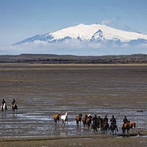
EXCURSIONS  Various excursions are available. For scheduled tours from Reykjavik you can check following websites.  Reykjavik Excursions offers discounts for NML participants  Reykjavík Excursions: RE  Iceland Exursions: www.icelandexcursions.is  Air Iceland: www.airiceland.is |  |  | 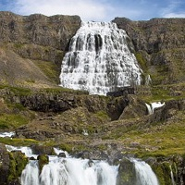

CAR RENTAL
Congress Reykajvik have partnered up with Hertz Iceland to offer congress participants a special discount off car hire.
Click here to activate discount

