**Hotel Information**

A number of rooms in different categories have been pre-booked for **SASP participants**.  
Breakfast is normally served at hotels between 07:00 to 10.00 every morning. All hotels have 24 hour lobby service. The check-in and check-out times at hotels are mostly as follows: check-in time from 14:00 and check–out time before 12:00. Please note, however, that this can vary from one hotel to another.

All prices include breakfast and all taxes

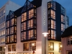**Plaza – Centerhotel \*\*\*** in Iceland provides the comfort and the location to enjoy Iceland to the fullest. Situated in the city Center of Reykjavik the Plaza creates the perfect setting for your stay in Iceland, with hotel bar and free high speed internet. The Hotel Plaza is located in the heart of the old city, next to restaurants, shopping and nightlife.

To see exact location and distance between hotel and congress venue [click here](https://www.google.is/maps/dir/Centerhotel+Plaza,+A%C3%B0alstr%C3%A6ti,+Reykjav%C3%ADk/deCODE+genetics,+Reykjav%C3%ADk/@64.1415222,-21.9527059,15z/data=!3m1!4b1!4m14!4m13!1m5!1m1!1s0x48d60b2d062ad4ff:0x16e32da51024770d!2m2!1d-21.9418913!2d64.1478712!1m5!1m1!1s0x48d60b377576e4e5:0x97e671b6b2cffa6!2m2!1d-21.9461274!2d64.1356595!3e2?hl=en)  
**Free wireless internet**  
**Address: Aðalstræti 4, 101 Reykjavík**

|  |  |  |
| --- | --- | --- |
| **Plaza - Centerhotel** | **Single room** | **Double room** |
| Superior | ISK 31.900 | ISK 34,.9400 |

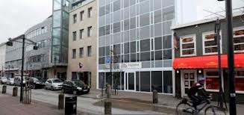**City Center Hotel** *** Is located in the heart of Reykjavik, Iceland´s capital. Standing six floors on one of the oldest streets in Reykjavik, Austurstraeti. All rooms have bathrooms with a shower and/or a bathtub. Some rooms have a great view over parliament square and some also have balconies. City Center Hotel offers its guests as a small gym, a coffee house on the ground floor and a souvenir shop in the reception area.

To see the exact location and distance between the hotel and congress venue [click here](https://www.google.com/maps/dir/City+Center+Hotel/deCODE+genetics,+Reykjav%C3%ADk,+Iceland/@64.1415784,-21.9517628,15z/data=!3m1!4b1!4m14!4m13!1m5!1m1!1s0x48d60b2d11fed8c9:0xfa8c6eec8658c09c!2m2!1d-21.9404874!2d64.1478704!1m5!1m1!1s0x48d60b377576e4e5:0x97e671b6b2cffa6!2m2!1d-21.9461274!2d64.1356595!3e2?hl=en)

**Free wireless internet**

**Address: Austurstraeti 6, 101 Reykjavik**

|  |  |  |
| --- | --- | --- |
| **City Center Hotel** | **Single room** | **Double room** |
| Standard | ISK 31.000 | ISK 39.800 |

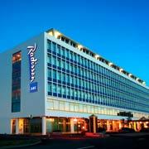**Saga – Radisson Blu\*\*\*\*** Overlooking the sea and city of Reykjavik  
Guests at this Reykjavik hotel can choose from one of 209 rooms and suites, each with fabulous views of the Reykjavik city centre, the sea or the beautiful campus of the University of Iceland. Each guest room seamlessly blends comfortable, modern furnishings with historic touches. All of the rooms in this hotel are equipped with a mini bar, as well as a satellite and pay-per-view TV.   
  
To see the exact location and distance between the hotel and congress venue [click here.](https://www.google.is/maps/dir/Radisson+Blu+Saga,+Reykjavik,+Capital+Region,+Europe/deCODE+genetics,+Reykjav%C3%ADk/@64.1377413,-21.9540151,16z/data=!3m1!4b1!4m14!4m13!1m5!1m1!1s0x48d60b306381b207:0x18668b6558a0f7db!2m2!1d-21.952328!2d64.141307!1m5!1m1!1s0x48d60b377576e4e5:0x97e671b6b2cffa6!2m2!1d-21.9461274!2d64.1356595!3e2?hl=en)  
**Free wireless internet**

**Address: at Hagatorg, 107 Reykjavík**

|  |  |  |
| --- | --- | --- |
| **Radisson Blu Saga prices** | Single room | Double room |
| Standard | ISK 44.000 | ISK 46.800 |

**[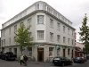](http://www.centerhotels.com/pictures/?album=1&gallery=1)Skjaldbreið – Center hotels \*\*\*** is located on Laugavegur, Reykjavik’s main shopping street, where the city is at its most vibrant. Hotel Skjaldbreið offers 33 rooms with private bathroom, satellite TV, telephone and high-speed internet connection. On the third floor a breakfast buffet is served every day between 7 and 10 AM in our comfortable sitting room. There you can sit down any time of day, relax and enjoy a complementary cup of coffee or tea, chat with fellow travellers or just enjoy the Reykjavik city scenery.  
  
To see the exact location and distance between the hotel and congress venue [click here](https://www.google.is/maps/dir/Centerhotel+Skjaldbreid,+Laugavegur,+Reykjavik,+Capital+Region/deCODE+genetics,+Reykjav%C3%ADk/@64.1406439,-21.9469739,15z/data=!3m1!4b1!4m14!4m13!1m5!1m1!1s0x48d674cd4051079f:0xc8d7802e480d379!2m2!1d-21.9307581!2d64.1459865!1m5!1m1!1s0x48d60b377576e4e5:0x97e671b6b2cffa6!2m2!1d-21.9461274!2d64.1356595!3e2?hl=en)

**Free wireless internet**

**Address: Laugavegur 16,101 Reykjavík**

|  |  |  |
| --- | --- | --- |
| **Hotel Skjaldbreið prices** | Single room | Double room |
| Standard | ISK 29.500 | ISK 31.900 |
| Double for Single use | ISK 31.900 |  |

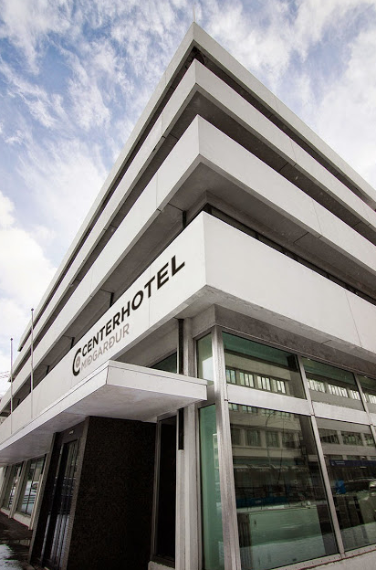

**Miðgarður – Center hotels \*\*\*** is the newest member of the CenterHotels family.  The hotel is ideally located in the heart of the city in short walking distance from the main attractions in Reykjavik.

The hotel has 43 modern and bright rooms.   All rooms are equipped with a private bathroom, mini-bar, coffee and tea making facilities, flat screen TV, free wi fi, shower, hairdryer and a safety deposit box.

To see the exact location and distance between the hotel and congress venue [click here](https://www.google.is/maps/dir/CenterHotel+Midgardur,+Reykjav%C3%ADk/deCODE+genetics,+Reykjav%C3%ADk/@64.1400216,-21.9392819,15z/data=!3m1!4b1!4m14!4m13!1m5!1m1!1s0x48d674c949d9c423:0x8f42cb4e0e53c73b!2m2!1d-21.914927!2d64.14308!1m5!1m1!1s0x48d60b377576e4e5:0x97e671b6b2cffa6!2m2!1d-21.9461274!2d64.1356595!3e2?hl=en)

**Free wireless internet**

**Address: Laugavegur,101 Reykjavík**

|  |  |  |
| --- | --- | --- |
| **Hotel Miðgarður prices** | Single room | Double room |
| Standard | ---- | ISK 33.100 |
| Double for Single use | ISK 31.900 | --- |